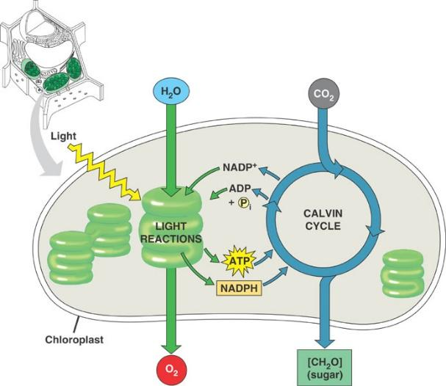

**Photosynthesis Virtual Lab**

In this virtual lab, you will each manipulate a variable to investigate how it influences the rate of photosynthesis. The four variables considered are light intensity, amount of carbon dioxide available, color of light, and temperature.

To measure photosynthetic rate, you will count the bubbles of Oxygen gas that are produced by a submerged *Elodea* plant.

1. Go to <http://www.kscience.co.uk/animations/photolab.htm>. Spend a few minutes clicking around on the animation to see what the different items do.
2. Discuss with your group who will investigate each of the variables. Two people will investigate the same variable. That’s okay. Record responsibilities here:
   1. Light Intensity: _____________
   2. Carbon Dioxide: ____________
   3. Light Color: ________________
   4. Temperature: ______________
3. From this point on, you will work independently. Write your experimental question.
4. Write a scientific hypothesis for your investigation. You must clearly reference the chemical processes of photosynthesis in your hypothesis and how your variable may affect them.
5. Design your experiment. Your experiment will be different from your group members.
   1. Independent variable
   2. Dependent variable
   3. Constants (3!)
   4. Control (I understand that you might not be able to actually complete an appropriate control for your variable in this animation – just tell me what *would* be the best control)
6. What “levels” of independent variable will you use? That is, what different settings are appropriate for your independent variable? This is dictated by the animation.
7. How many trials will you complete at each level of independent variable? (Note: Since this is an animation, it is extraordinarily consistent – very unlike real life. That said, you still need to do repeated trials so you have a sufficient ‘n’ for your statistical analysis).
8. Think: Why is counting oxygen bubbles an appropriate measure of photosynthetic rate? The answer to this question will work its way into your CER.
9. Complete your experiment! Create a data table and graph your data. Depending on your experiment, this might be a line graph or a bar graph – you decide!
10. Complete a statistical test to determine the validity of your scientific hypothesis.
11. Write a scientific conclusion/CER for your experiment – NOT MORE than 5 sentences.

**Delete this text and type your Experimental Question here!**

Data Table: Graphical Representation: (Hand drawn is okay)

|  |  |  |  |
| --- | --- | --- | --- |
|  |  |  |  |
|  |  |  |  |
|  |  |  |  |
|  |  |  |  |
|  |  |  |  |
|  |  |  |  |
|  |  |  |  |
|  |  |  |  |

